## [AA - How Many Divisors?](https://vjudge.net/problem/Aizu-ITP1_3_D" \t "_blank)

 #include<bits/stdc++.h>

using namespace std;

int main()

{

int a,b,c;

cin>>a>>b>>c;

int count=0;

for(int i=a ;i<=b;i++)

{

if(c%i==0)

count++;

}

cout<<count;

}

## Sample Input 1

5 14 80

## Sample Output 1

3

## [AB - Volume Control](https://vjudge.net/problem/CodeChef-VOLCONTROL)

 #include<bits/stdc++.h>

using namespace std;

int main()

{

int t;

cin>>t;

while(t--)

{

int num1,num2;

cin>>num1>>num2;

if(num1>num2)

{

cout<<num1-num2<<"\n";

}

else

{

cout<<num2-num1<<"\n";

}

}

}

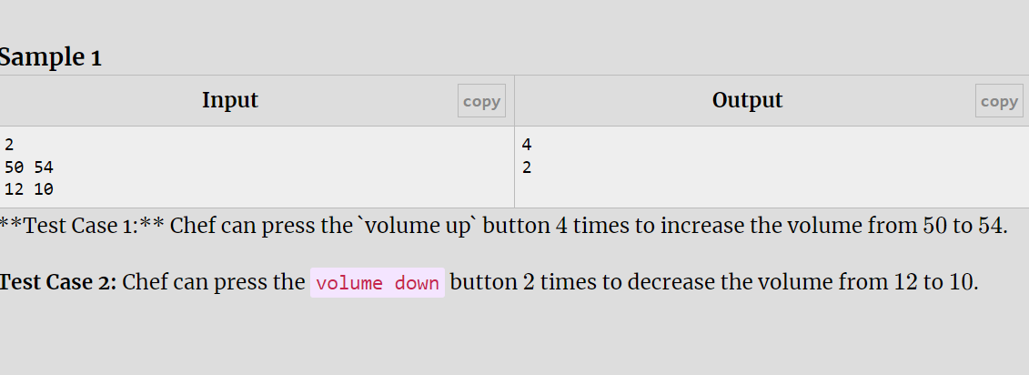

## [AC - Ezio and Guards](https://vjudge.net/problem/CodeChef-MANIPULATE)

 #include<bits/stdc++.h>

using namespace std;

int main()

{

int t;

cin>>t;

while(t--)

{

int num1,num2;

cin>>num1>>num2;

if(num1<num2)

{

cout<<"N0"<<"\n";

}

if(num1==num2)

{

cout<<"YES"<<"\n";

}

if(num1>num2)

{

cout<<"YES"<<"\n";

}

}

}

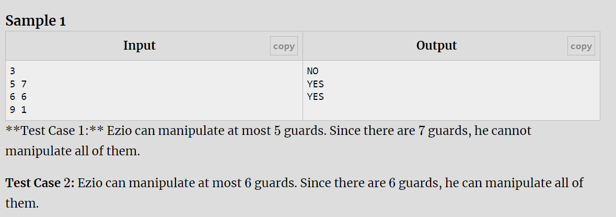

## [AD - Credit score](https://vjudge.net/problem/CodeChef-CREDSCORE)

 #include<bits/stdc++.h>

using namespace std;

int main()

{

int cred;

cin>>cred;

if(cred>=750)

{

cout<<"YES"<<"\n";

}

else

{

cout<<"NO"<<"\n";

}

}

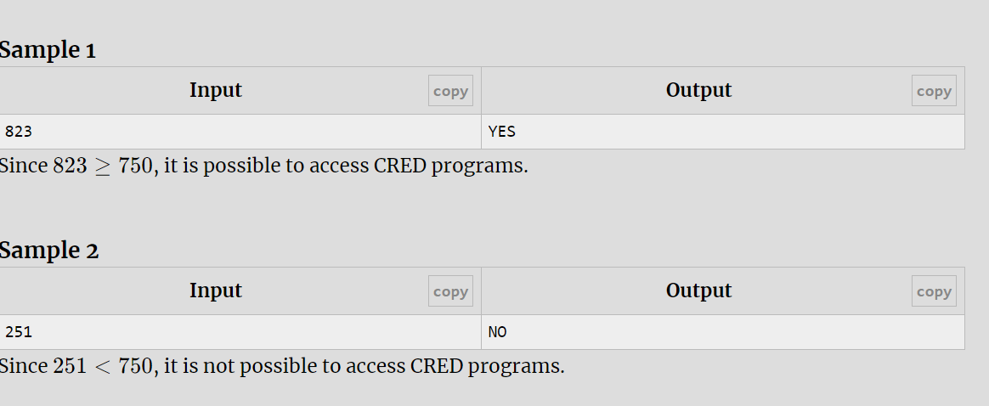

## [AE - Course Registration](https://vjudge.net/problem/CodeChef-COURSEREG)

 #include<bits/stdc++.h>

using namespace std;

int main()

{

int t;

cin>>t;

while(t--)

{

int N,M,K;

cin>>N>>M>>K;

int capacity=N+K;

if(capacity<=M)

{

cout<<"Yes"<<"\n";

}

else

{

cout<<"No"<<"\n";

}

}

}

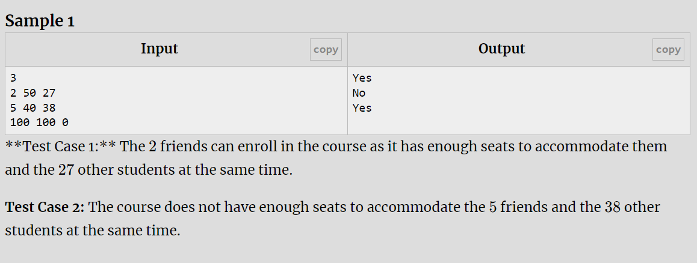

## [AF - Increase IQ](https://vjudge.net/problem/CodeChef-INCRIQ)

 #include<bits/stdc++.h>

using namespace std;

int main()

{

int iq;

cin>>iq;

int totaliq=iq+7;

if(totaliq>170)

{

cout<<"Yes"<<"\n";

}

else

{

cout<<"No"<<"\n";

}

}

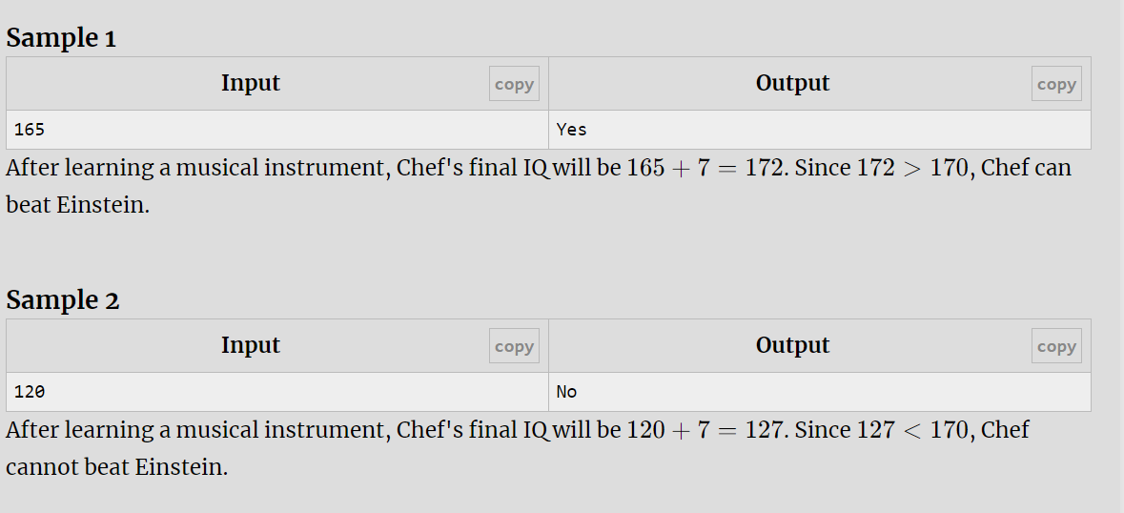

## [AG - Miami GP](https://vjudge.net/problem/CodeChef-F1RULE)

 #include<bits/stdc++.h>

using namespace std;

int main()

{

float t;

cin>>t;

while(t--)

{

float x,y;

cin>>x>>y;

int race=x\*1.07;

if(race>=y)

{

cout<<"YES"<<"\n";

}

else

{

cout<<"NO"<<"\n";

}

}

}

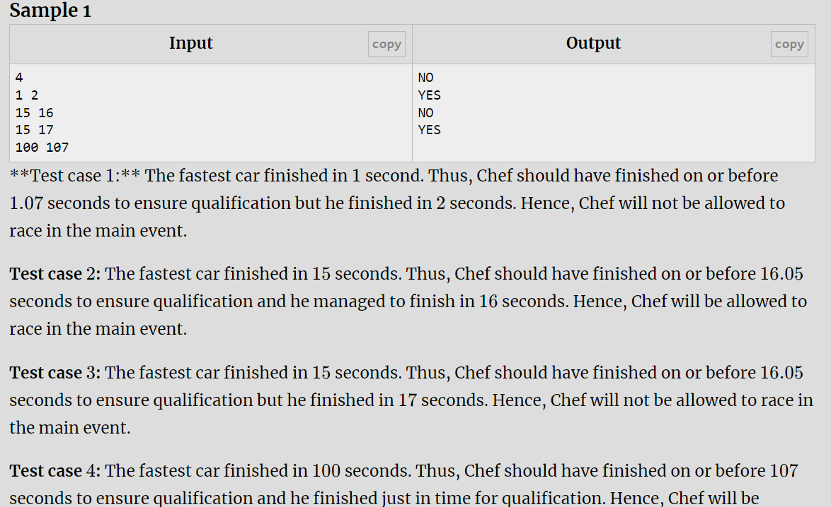

[AH - Is the Score Consistent](https://vjudge.net/problem/CodeChef-TRUESCORE)

#include<bits/stdc++.h>

using namespace std;

int main()

{

int t;

cin>>t;

while(t--)

{

int a,b,c,d;

cin>>a>>b;

cin>>c>>d;

if(c>=a && d>=b)

{

cout<<"POSSIBLE"<<"\n";

}

else

{

cout<<"IMPOSSIBLE"<<"\n";

}

}

}

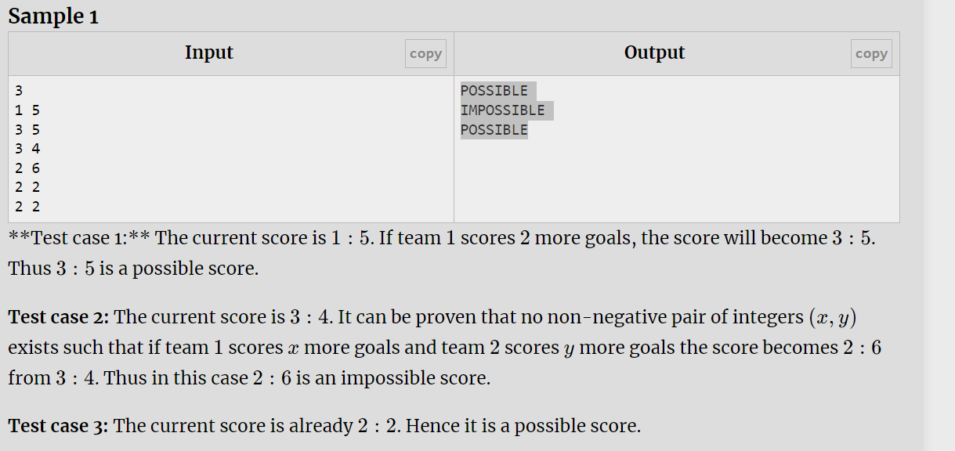

## [AI - The Three Topics](https://vjudge.net/problem/CodeChef-THREETOPICS)

 #include<bits/stdc++.h>

using namespace std;

int main()

{

int a,b,c,x;

cin>>a>>b>>c>>x;

if(a==x || b==x || c==x)

{

cout<<"Yes"<<"\n";

}

else

{

cout<<"No"<<"\n";

}

}

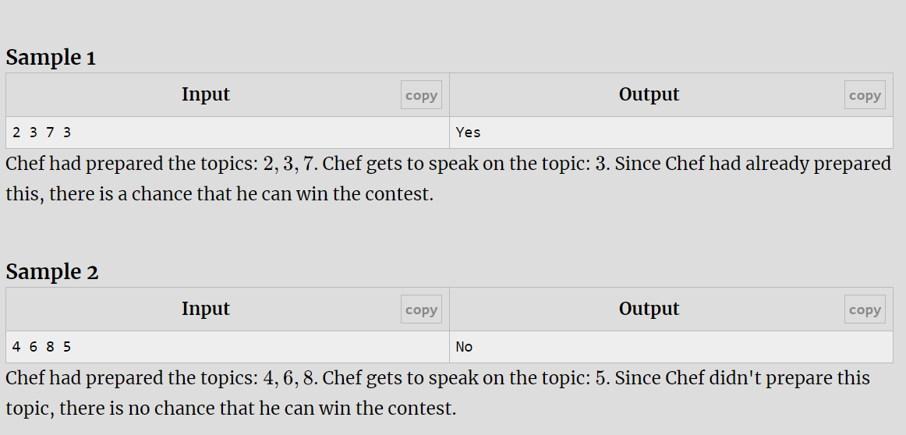

## [AJ - Number of multiples](https://vjudge.net/problem/HackerRank-si-basic-number-of-multiples)

 #include<bits/stdc++.h>

using namespace std;

int main()

{

int num;

cin>>num;

int count=0;

for(int i=1;i<=num;i++)

{

if(i%5==0 || i%3==0)

{

count++;

}//Multiples of 3 and 5 in range of 1 to 12 are 3, 5, 6, 9, 10, 12.

}

cout<<count;

}

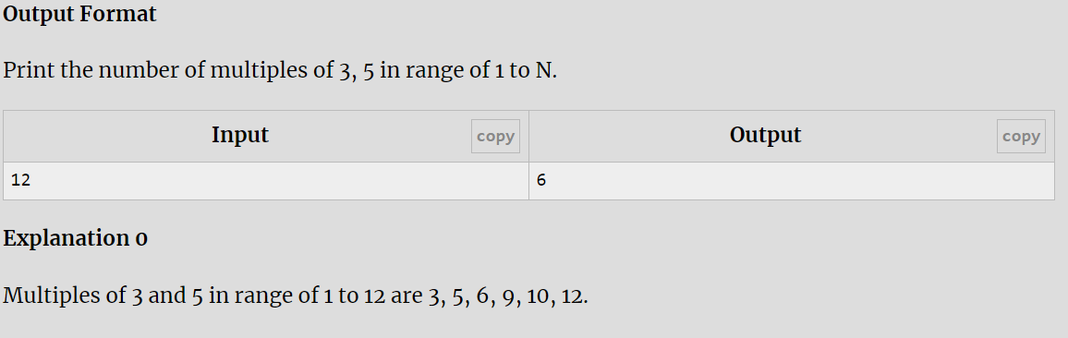

## [AK - Tax in Chefland](https://vjudge.net/problem/CodeChef-TAXES)

 #include<bits/stdc++.h>

using namespace std;

int main()

{

int t;

cin>>t;

while(t--)

{

int num;

cin>>num;

if(num>100)

{

cout<<num-10<<"\n";

}

else

{

cout<<num<<"\n";

}

}

}

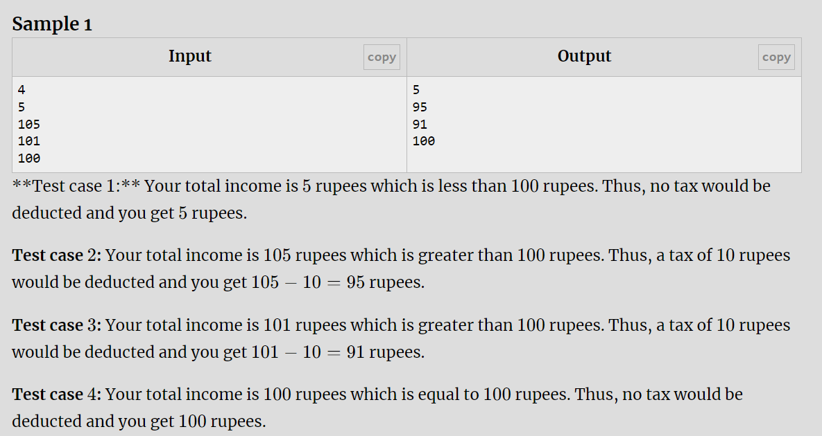

## [AL - Team](https://vjudge.net/problem/CodeForces-231A)

 #include<bits/stdc++.h>

using namespace std;

int main()

{

int n;

cin>>n;

int count=0;

for(int i=0;i<=n;i++)

{

int q1,q2,q3;

cin>>q1>>q2>>q3;

if(q1+q2+q3>=2)

{

count++;

}

}

cout<<count;

}

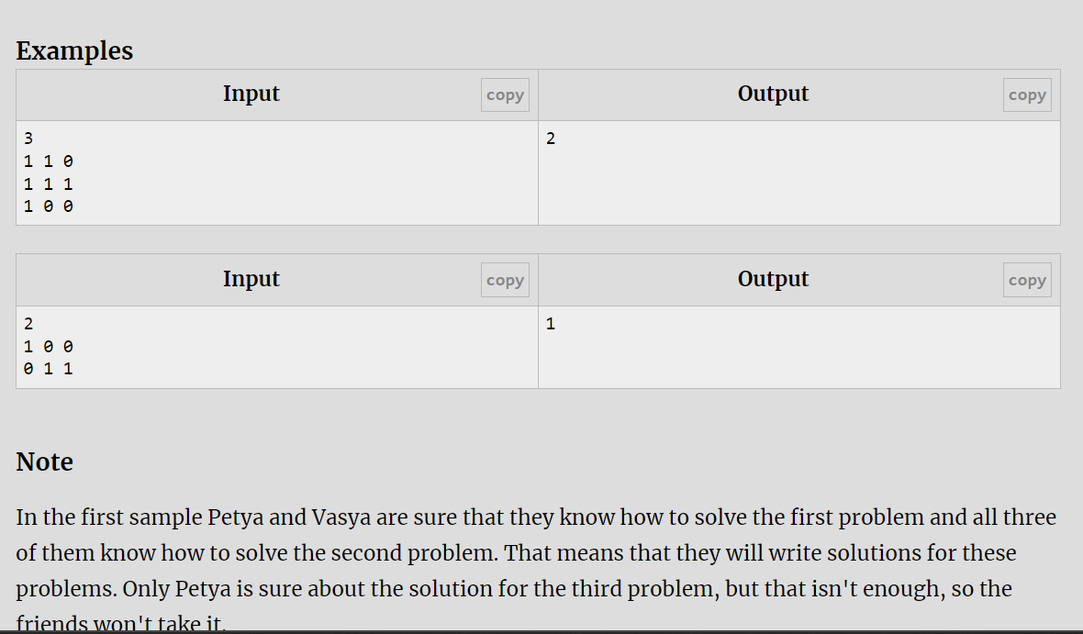

## [AO - Greater Average](https://vjudge.net/problem/CodeChef-AVGPROBLEM)

 #include<bits/stdc++.h>

using namespace std;

int main()

{

int t;

cin>>t;

while(t--)

{

int a,b,c;

cin>>a>>b>>c;

if(a+b>2\*c)

cout<<"yes"<<endl;

else

cout<<"no"<<endl;

}

return 0;

}

